**SIMULATION AND MODELING**

**CS-6647**

**SIMULATION for RICE MILLS**

**INTRODUCTION**

**SIMULATION:**

Simulation is the imitation of the operation of a real-world process or system over time. The act of simulating something first requires that a model be developed; this model represents the key characteristics or behaviors/functions of the selected physical or abstract system or process.

Simulation is used in many contexts, such as simulation of [technology](https://en.wikipedia.org/wiki/Technology) for performance optimization, [safety engineering](https://en.wikipedia.org/wiki/Safety_engineering), [testing](https://en.wikipedia.org/wiki/Experiment), [training](https://en.wikipedia.org/wiki/Training), [education](https://en.wikipedia.org/wiki/Education), and [video games](https://en.wikipedia.org/wiki/Video_game). Often, [computer experiments](https://en.wikipedia.org/wiki/Computer_experiment) are used to study simulation models. Simulation is also used with [scientific modelling](https://en.wikipedia.org/wiki/Scientific_modelling) of natural systems or human systems to gain insight into their functioning. Simulation can be used to show the eventual real effects of alternative conditions and courses of action. Simulation is also used when the real system cannot be engaged, because it may not be accessible, or it may be dangerous or unacceptable to engage, or it is being designed but not yet built, or it may simply not exist.

**BENEFITS OF SIMULATION:**

-Quick and easy to use.

-Versatile enough to model any system.

-Captures system dynamics and variation.

-Shows system behavior over time.

-Animation provides effective communication.

**SIMULATION for RICE MILLS:**

**Introduction:**

[**Rice**](http://omicsonline.org/searchresult.php?keyword=rice)  has been the staple food for more than half of the humanity in the world or two-third of the World’s population. Rice is the seed or kernel of paddy, which is covered by two different layers, namely- bran (inner layer) and husk (outer layer). Literally, paddy becomes rice only when the two layers are removed properly through different milling processes. In the first step, brown rice is extracted by removing hull/husk from the paddy, which contains bran layer still intact around the kernel. In the second step, the bran layer is removed by polishing machine that rubs the grains together under pressure, and the output is the polished white kernel or fine rice. The former process is known as hulling and the latter is known as milling of paddy. But, in short, it is the conversion ratio from paddy to rice, or one can term it as hulling and milling ratio.

In term of production, India has become the second largest producer of rice in the world (21 per cent of global rice production), next to China. As on 2009, rough total production of [**paddy**](http://omicsonline.org/searchresult.php?keyword=paddy)  was 14, 8260 thousand MT in the country, but, as estimated by USDA, it was 13, 2013 thousand MT. On the demand side, India’s domestic consumption was, on an average, 95% of what it produced and was still the third largest exporter of rice, after Thailand and Vietnam, with about 20% of the world’s total rice exports in 2006-07. In the recent years, with the growth of population, more pressure on the arable land has been made and this in turn, the need for higher productivity of crops was felt in the country. At the same time, large quantity of food grain was reported to be lost due to inefficient milling processes in the country. Therefore, it calls for a better processing technique of rice to prevent processing loss.

Generally, rice kernels are often susceptible to breakage due to inefficient milling processes. Therefore, more efficient milling processes are highly recommended for better recovery ratio and [**quality rice**](http://omicsonline.org/searchresult.php?keyword=quality-rice) kernel production. It is also identified as one of the most important remedies for preventing post-harvest loss and an issue that is widely recognized around the world. With the facts mentioned above, this study tries to explore the conversion ratio of paddy in India by two different milling techniques– modern and traditional mills. Variation in the conversion ratio among the Indian States is analyzed along with an inter-state comparison of conversion ratios.

**Objective:**

In rice mills white rice and bran are out coming products. These two products are getting Same exit location with different time.

We are proposed that creating two exit fields for two products.so These two products are getting different exit location with same time.

* Less Waiting time for Previous system.
* Compare to previous system, more number of rice and bran packets are collecting. So production values are increased.

# Project plan:

Simulation is the imitation of a dynamic system using a computer model in order to evaluate and improve system performance. Simulation is used before an existing system and finding the important and implement the changing the new simulation inputs.

**PROJECT LAYOUT:**

**Rice Mills**

The current rice mill system has only basic move and wait logic. According to current system paddy enters the entry field and the waits for specified amount of time. There is no limit to the entry as infinite number of paddy packets can enter the entry field. Once entry these paddy packets moves to bran factory. In bran factory two products are divided. Waste and brown rice. Brown rice is moves to another factory i.e. white rice factory. In white rice factory bran and white rice is divided. After these processing we are getting white rice and bran these two products are getting Same exit location with different time intervals.

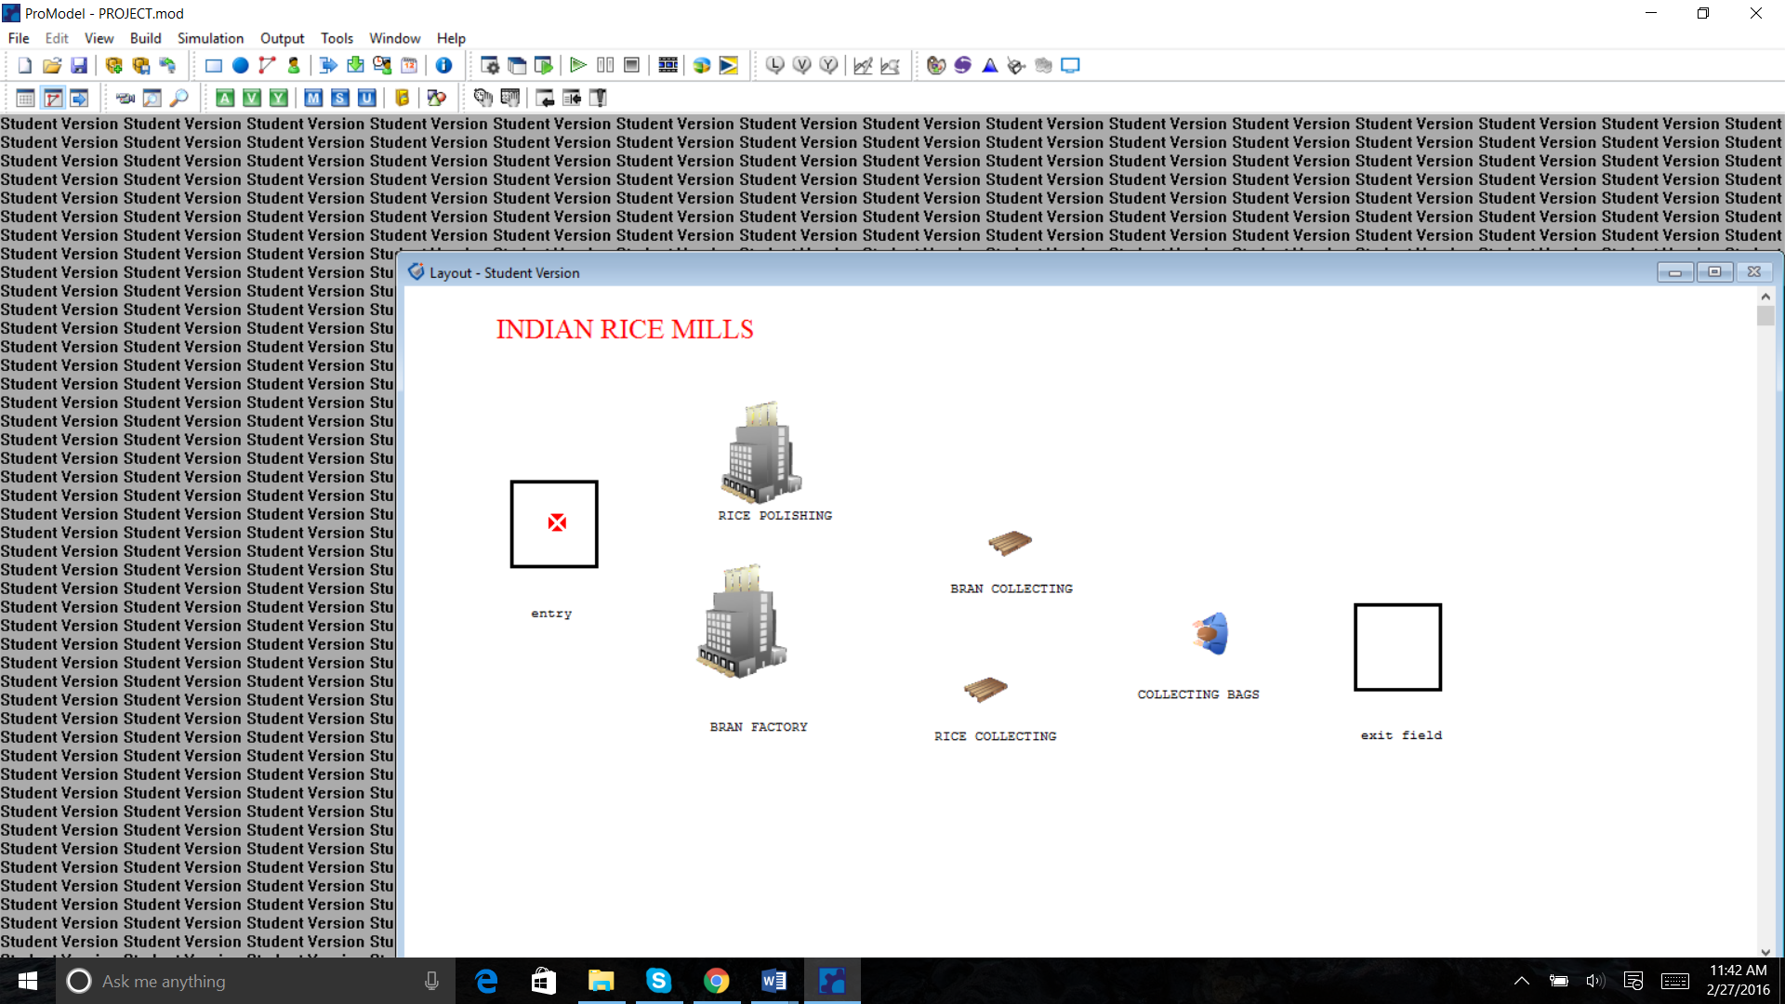

# Proposed system:

The proposed rice mill system also moves and wait logic. But According to proposed system paddy enters the entry field and the waits for specified amount of time. There is no limit to the entry as infinite number of paddy packets can enter the entry field. Once entry these paddy packets moves to bran factory. In bran factory two products are divided. white rice and bran is moves to another factory i.e. white rice factory. In white rice is polished. After these processing we are getting white rice and bran these two products are getting two exit location with same time intervals.

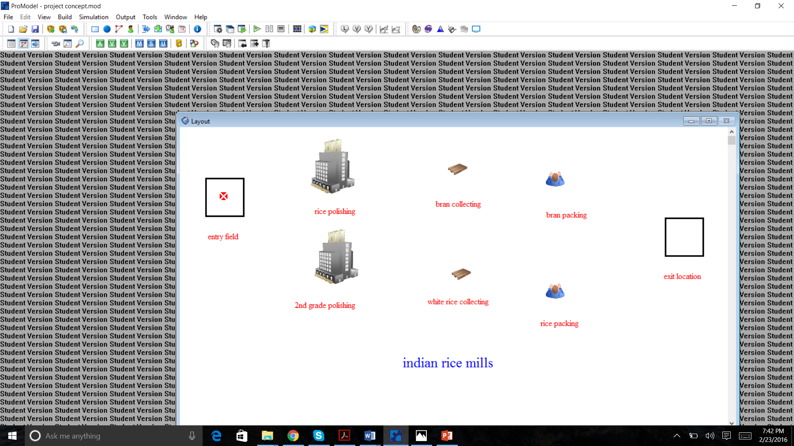

# Proposed system or Experimental System Design:

* Simulation starts by building the resource by selecting the Locations, Entities, Processing and Arrivals.
* Formulate a hypothesis by adjusting a capacity, routing the paths.
* Select the options in simulation icon, writing code, adjust a run time.
* Save the pro-model and run into the output by analysis, by ending the simulation.
* Step 1. Identify the problem.
* Step 2. Formulate the problem.
* Step 3. Collect and process real system data.
* Step 4. Formulate and develop a model.
* Step 5. Validate the model.
* Step 6. Document model for future use.

# Software Used:

* For the domain knowledge a popular rice mills in India was studied. The proposed simulation technique will Compare to previous system, more number of rice and bran packets are collecting. So production values are increased.

.

The simulation approach to this project which involves the entire experience of an entity as its flows through the system. In this project PRO-MODEL has been used to model the application environment.

# Simulation Model:

Firstly, a current model with all the loop holes and real scenarios should be developed in order to replicate the exact time and wait duration. Keeping the wait & time constraints into consideration, a new and proposed model is developed trying to eliminate all the loop holes and maximizing satisfaction and profit.

**LOCATIONS:**

* entry field
* Rice Polishing
* 2nd grade polishing
* Bran collecting
* Rice collecting
* Rice packing
* Bran packing
* Exit field

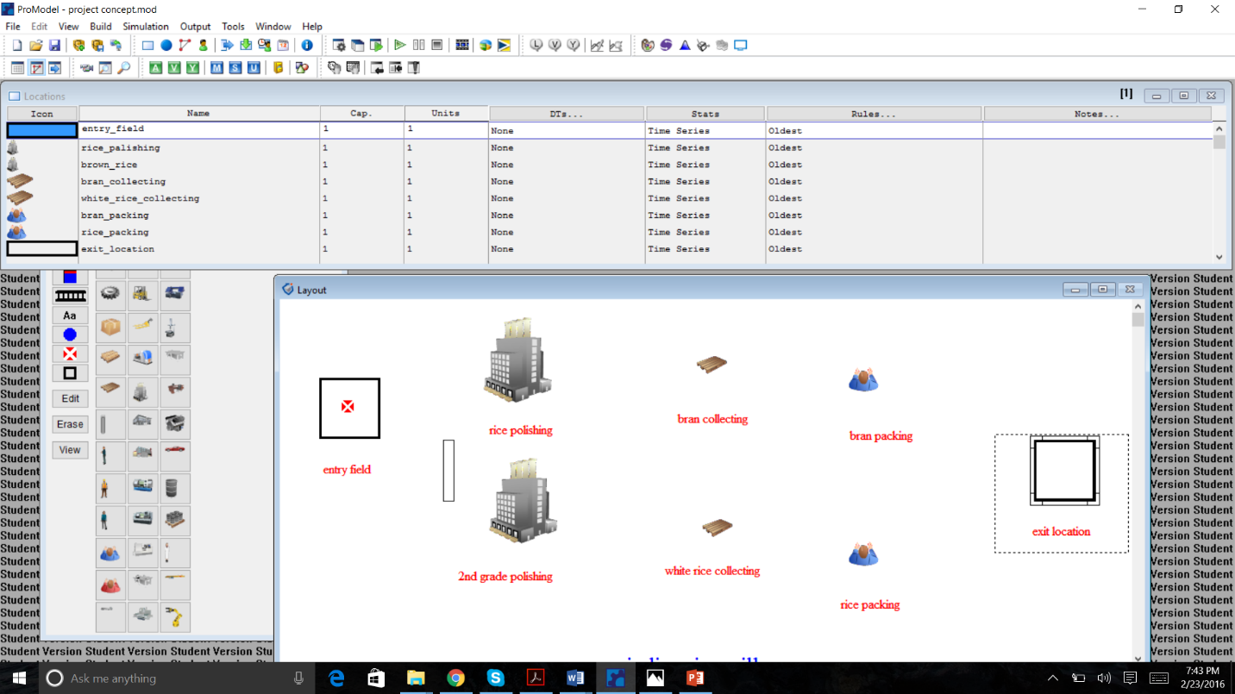

The specifications for all the locations can be seen from the above.

ENTITIES:

The items processed through the system, such as customers in a bank.

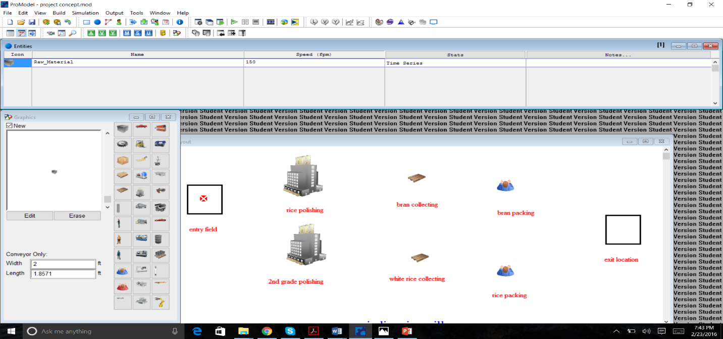

**ARRIVALS:**

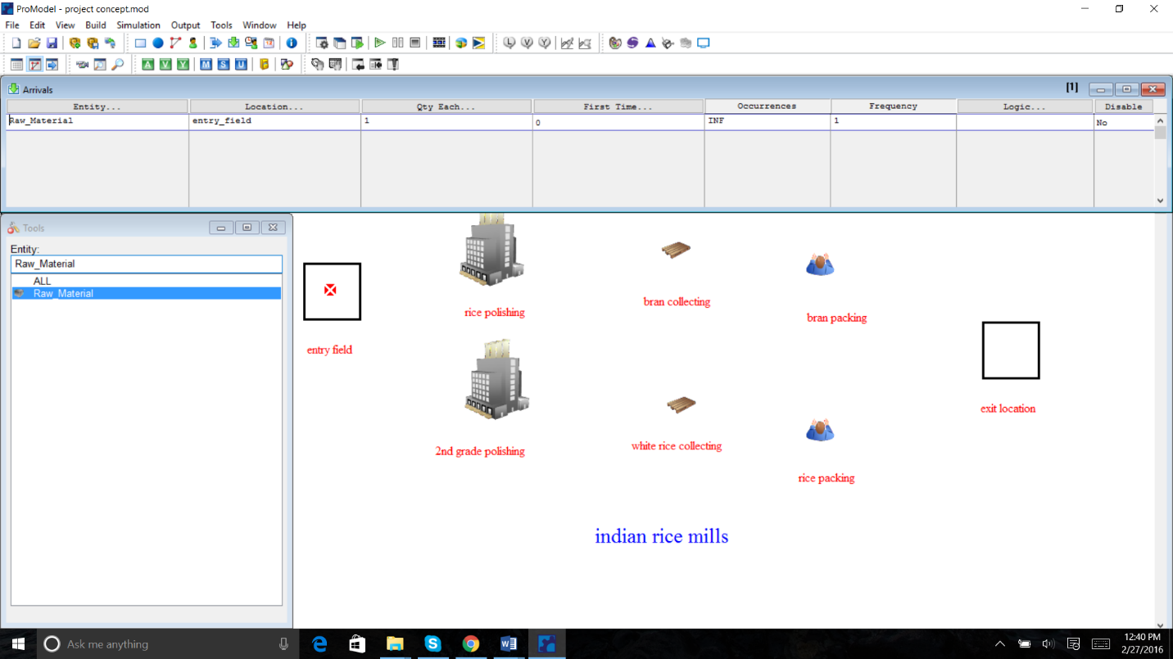

PROCESS:

Input processes (entities, location & Operation):

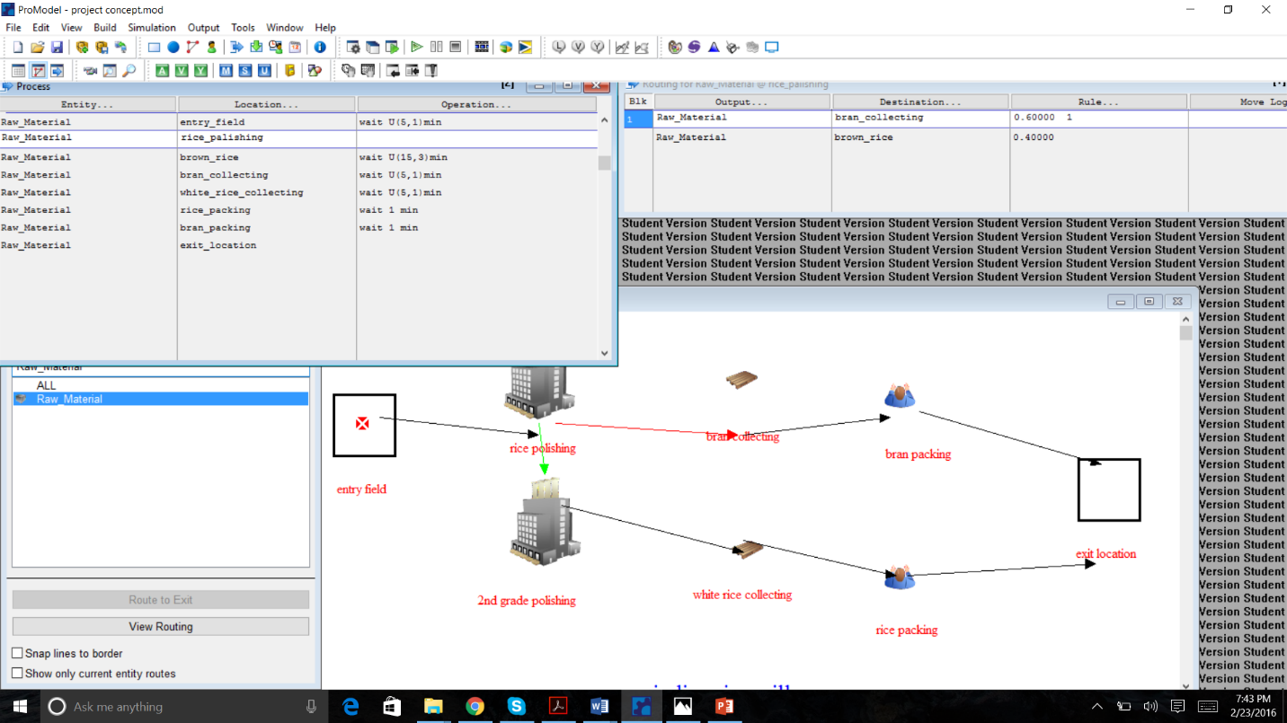

**SIMULATION for RICE MILLS IN INDIA**

**Simulation for a period of 100 hrs. (current system)**

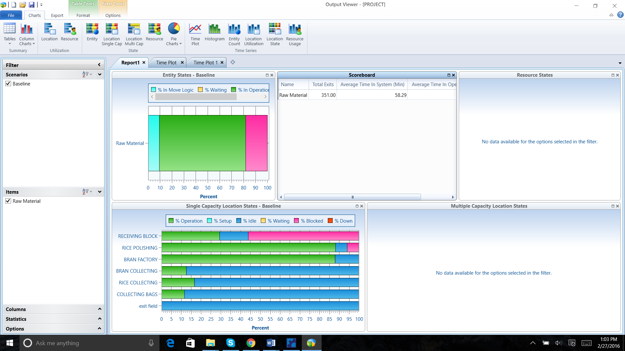

**Simulation for a period of 100 hrs. (propose system)**

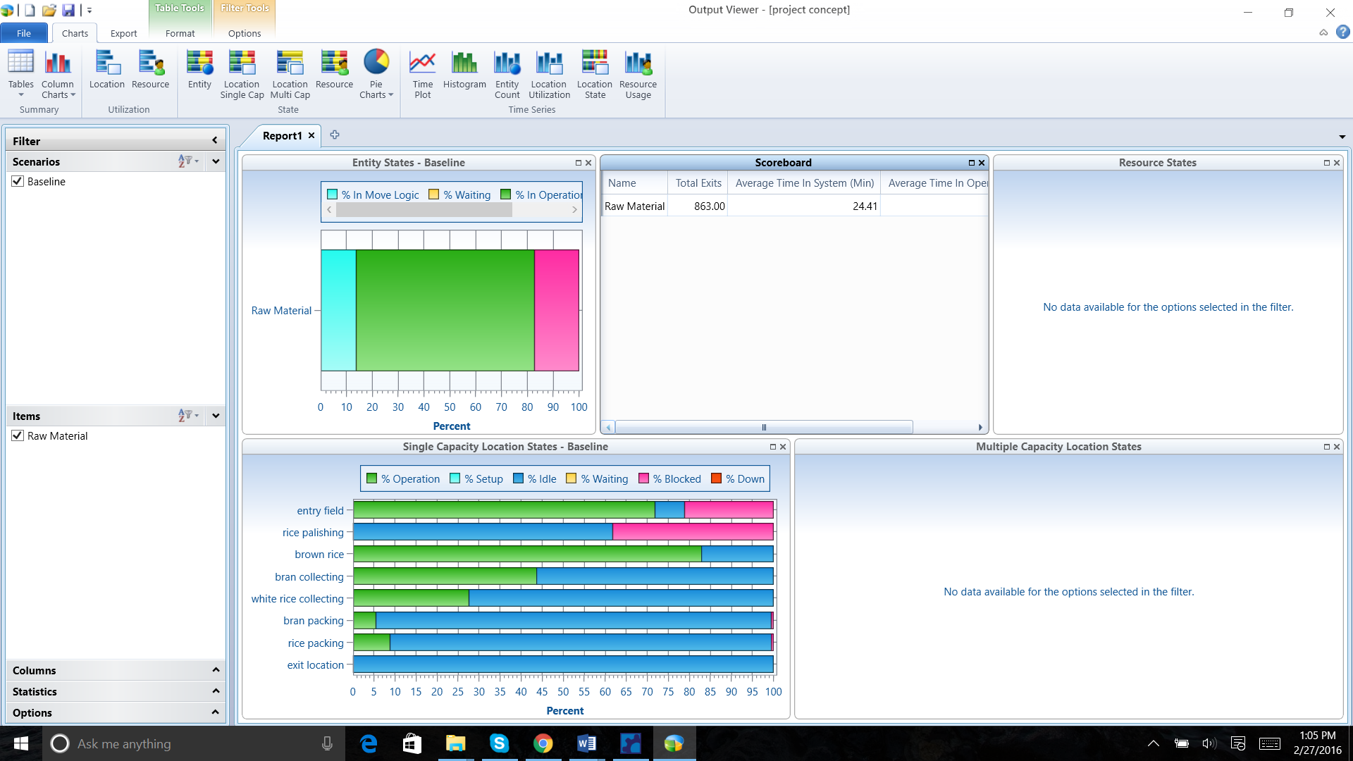

All of the layouts and the simulation outputs of the proposed system are in the figure.

**Summary Report**

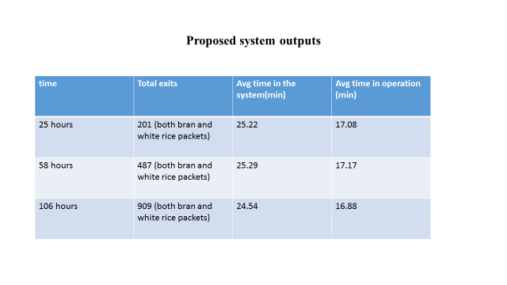

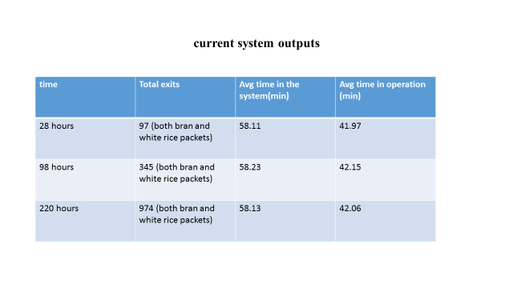

**Conclusion:**

Present rice mill system takes more time to produce rice packets and bran packets. So improve some modifications, then resulting a new system performance with good results.